WEEK 7

🛠️ Step 1: Configure Tunnel Interface

R1
interface tunnel 0
ip address 172.16.1.1 255.255.255.252
tunnel source g0/1
tunnel destination 200.1.1.6
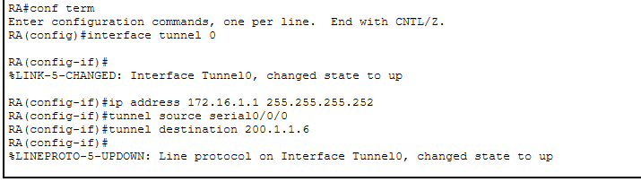

R2
interface tunnel 0
ip address 172.16.1.2 255.255.255.252
tunnel source g0/1
tunnel destination 200.1.1.2
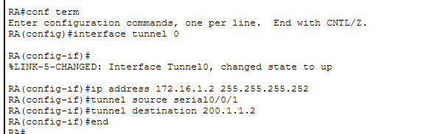

🛠️ Step 2: Route Traffic Through Tunnel
ip route 192.168.2.0 255.255.255.0 172.16.1.2
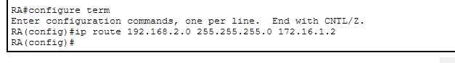

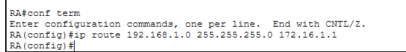

✅ Verification
show interface tunnel 0
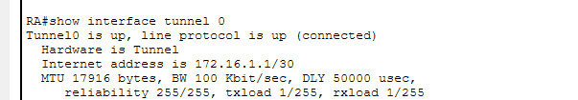
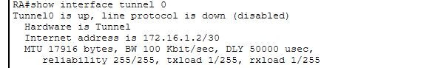
ping remote LAN
✔ Offices communicate as if locally connected.

